DAA PRACTICAL 5

TASK 1:
Find the similarity between the given X and Y sequence.
X=AGCCCTAAGGGCTACCTAGCTT
Y= GACAGCCTACAAGCGTTAGCTTG
//longest common sequence(LCS)
#include <stdio.h>
#include <string.h>

int max(int a, int b)
{
return a > b ? a : b;
}
void LCS(char *X, char *Y) { int m = strlen(X), n = strlen(Y);
int dp[m+1][n+1];
// Fill DP table
for (int i = 0; i <= m; i++)
for (int j = 0; j <= n; j++)
if (i == 0 || j == 0) dp[i][j] = 0;
else if (X[i-1] == Y[j-1])
dp[i][j] = dp[i-1][j-1] + 1;
else
dp[i][j] = max(dp[i-1][j], dp[i][j-1]);
// Backtrack to get LCS int i = m, j = n, k = dp[m][n];
char lcs[k+1];
lcs[k] = '\0';
while (i > 0 && j > 0) {
if (X[i-1] == Y[j-1]) {
lcs[--k] = X[i-1];
i--; j--;
} else if (dp[i-1][j] > dp[i][j-1])
i--; else
j--;
}
printf("LCS Length: %d\n", dp[m][n]);
printf("LCS: %s\n", lcs);
}

int main() {
char X[] = "AGCCCTAAGGGCTACCTAGCTT";
char Y[] = "GACAGCCTACAAGCGTTAGCTTG";
LCS(X, Y);
return 0;
}

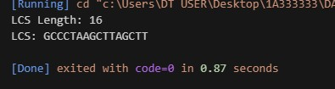

TASK-2:
Find the longest repeating subsequence (LRS). Consider it as a variation of the longest common subsequence (LCS) problem.
// longest repeating sequence(LRS)
#include <stdio.h>
#include <string.h>

int max(int a, int b)
{
return a > b ? a : b;
}
void LRS(char *str) {
int n = strlen(str); int dp[n+1][n+1];
// Fill DP table
for (int i = 0; i <= n; i++)
for (int j = 0; j <= n; j++)
if (i == 0 || j == 0)
dp[i][j] = 0;
else if (str[i-1] == str[j-1] && i != j) dp[i][j] = dp[i-1][j-1] + 1;
else
dp[i][j] = max(dp[i-1][j], dp[i][j-1]);
// Backtrack to get LRS
int i = n, j = n, k = dp[n][n];
char lrs[k+1];
lrs[k] = '\0'; while (i > 0 && j > 0) {
if (str[i-1] == str[j-1] && i != j) {
lrs[--k] = str[i-1];
i--; j--;
} else if (dp[i-1][j] > dp[i][j-1])
i--;
else j--;
}
printf("LRS Length: %d\n", dp[n][n]);
printf("LRS: %s\n", lrs);
}
int main() {
char S[] = "AABCBDC";
LRS(S); return 0;
}

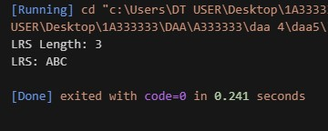

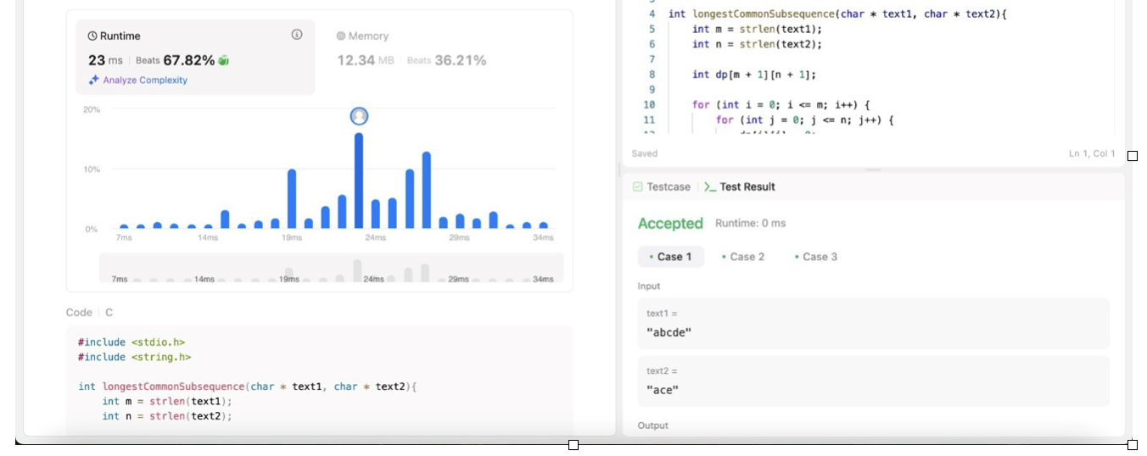
LEETCODE:
